Granger predictability: USDCHF and EURGBP
Method 13 / daily log returns / p=1 and p=5 / Alpari D1 full available history

Study setup
Logical pair: USDCHF , EURGBP
Broker symbols: USDCHF_i , EURGBP_i
Snapshot: 2026-11-03_majors_alpari_D1
Timeframe: D1
Matched return window: 1999-01-06 to 2026-11-02 (UTC bar dates)
Matched return count n: 7182
Dropped unfinished last bar dated 2026-11-03 UTC after a tick-volume check against the prior complete day.
Lag orders pre-specified: p=1 and p=5; both directions
Headline: p=5 joint F test in both directions
Complete matched rows (Excel): USDCHF-EURGBP_Granger_D1.xlsx
Complete matched rows (HTML table): USDCHF-EURGBP_Granger_D1_data.html

Method carried forward
Granger predictability asks whether lagged X helps explain Y beyond lags of Y alone on matched daily log returns of close, ln(close_t / close_t-1). Quotes are not inverted. For lag order p, the unrestricted model is y_t on an intercept, y_{t-1}..y_{t-p}, and x_{t-1}..x_{t-p}. The restricted model drops the x lags. The test is an F comparison of residual sums of squares via OLS (numpy.linalg.lstsq) and scipy.stats.f. Orders p=1 and p=5 are pre-specified; both directions are tested. The headline is the p=5 joint test in both directions. p=1 is reported beside it because the guide formula is the one-lag regression. Rejecting H0 is statistical predictability in mean in this sample; it is not economic causation and not a trading signal. There are 56 directed tests at p=5 across the 28 pairs.

Results
direction | p_lags | n | f_stat | p_value | b | df1 | df2
USDCHF_to_EURGBP | 1 | 7181 | 8.3267981 | 0.00391809 | 0.0266187 | 1 | 7178
USDCHF_to_EURGBP | 5 | 7177 | 1.8520571 | 0.09926969 | nan | 5 | 7166
EURGBP_to_USDCHF | 1 | 7181 | 0.14138921 | 0.70691495 | 0.00633981 | 1 | 7178
EURGBP_to_USDCHF | 5 | 7177 | 1.6268169 | 0.14915307 | nan | 5 | 7166

Conclusion
Headline p=5 joint tests for USDCHF and EURGBP: USDCHF->EURGBP F=1.8521 (p=0.0992697); EURGBP->USDCHF F=1.6268 (p=0.149153); usable rows n=7177. One-lag slopes: b_USDCHF->EURGBP=0.0266 (F=8.3268, p=0.00391809); b_EURGBP->USDCHF=0.0063 (F=0.1414, p=0.706915). Rejecting H0 is in-sample mean predictability, not economic cause and not a trading signal.

Charts
Daily closes

Daily log returns

Granger F statistics
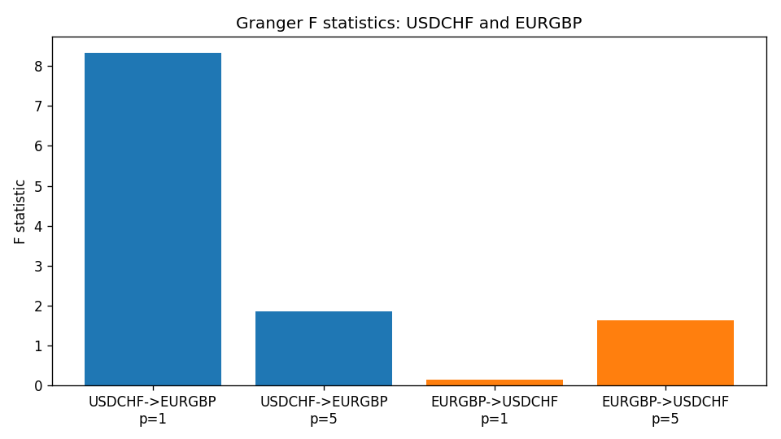

Data report
Every matched row is stored in the sibling Excel workbook named USDCHF-EURGBP_Granger_D1.xlsx (sheet matched_rows). The results sheet holds the four F tests. Embedding all rows as a Word table is impractical; the Word file holds column summaries and the first and last 15 rows.
Columns: time, USDCHF_open, EURGBP_open, USDCHF_high, EURGBP_high, USDCHF_low, EURGBP_low, USDCHF_close, EURGBP_close, USDCHF_tick_volume, EURGBP_tick_volume, USDCHF_spread, EURGBP_spread, USDCHF_real_volume, EURGBP_real_volume, USDCHF_log_return, EURGBP_log_return
Column summaries (matched calculation rows)
column | count | mean | std | min | 25% | 50% | 75% | max
USDCHF_open | 7182 | 1.0972493 | 0.25210985 | 0.72022 | 0.9204925 | 0.989875 | 1.237175 | 1.8219
EURGBP_open | 7182 | 0.7869939 | 0.09664695 | 0.5734 | 0.6877 | 0.833905 | 0.865225 | 0.9769
USDCHF_high | 7182 | 1.1025378 | 0.25385182 | 0.73305 | 0.924695 | 0.99351 | 1.242175 | 1.8313
EURGBP_high | 7182 | 0.79007306 | 0.09702085 | 0.5789 | 0.6897 | 0.836955 | 0.8681 | 0.9799
USDCHF_low | 7182 | 1.092133 | 0.25052689 | 0.08565 | 0.9171825 | 0.986205 | 1.2312 | 1.8121
EURGBP_low | 7182 | 0.7842938 | 0.09646529 | 0.5682 | 0.685725 | 0.83166 | 0.86287 | 0.9661
USDCHF_close | 7182 | 1.09724 | 0.25200902 | 0.72025 | 0.9207375 | 0.98991 | 1.23715 | 1.8217
EURGBP_close | 7182 | 0.78703952 | 0.09664503 | 0.5735 | 0.687825 | 0.83398 | 0.865375 | 0.977
USDCHF_tick_volume | 7182 | 74362.695 | 113509.88 | 18 | 12814.25 | 40258.5 | 70446 | 858589
EURGBP_tick_volume | 7182 | 87145.49 | 145506.26 | 154 | 6593.75 | 44371 | 81432 | 1424684
USDCHF_spread | 7182 | 26.020746 | 24.692144 | 0 | 5 | 16 | 50 | 100
EURGBP_spread | 7182 | 21.320663 | 19.117614 | 0 | 4 | 13 | 40 | 50
USDCHF_real_volume | 7182 | 2.3303821e+10 | 8.915094e+10 | 0 | 0 | 0 | 0 | 1.9331921e+12
EURGBP_real_volume | 7182 | 2.7876168e+10 | 1.3522356e+11 | 0 | 0 | 0 | 0 | 3.5726265e+12
USDCHF_log_return | 7182 | -7.199e-05 | 0.00659004 | -0.19545699 | -0.00335239 | 7.626e-05 | 0.00331734 | 0.09051364
EURGBP_log_return | 7182 | 2.529e-05 | 0.00487429 | -0.03067367 | -0.00262165 | -0.00010006 | 0.00256425 | 0.06075387
First 15 matched rows (selected columns)
time | USDCHF_close | EURGBP_close | USDCHF_log_return | EURGBP_log_return
1999-01-06 | 1.3912 | 0.7019 | 0.013605652 | -0.013303338
1999-01-07 | 1.3782 | 0.7097 | -0.0093883841 | 0.011051402
1999-01-08 | 1.3935 | 0.7062 | 0.011040268 | -0.004943862
1999-01-11 | 1.4009 | 0.7053 | 0.0052963193 | -0.0012752393
1999-01-12 | 1.3872 | 0.7077 | -0.0098275602 | 0.0033970309
1999-01-13 | 1.3621 | 0.708 | -0.018259701 | 0.00042381861
1999-01-14 | 1.3588 | 0.7066 | -0.0024256692 | -0.0019793588
1999-01-15 | 1.3834 | 0.7012 | 0.01794228 | -0.0076715819
1999-01-18 | 1.379 | 0.7017 | -0.0031856384 | 0.00071280921
1999-01-19 | 1.3789 | 0.7007 | -7.2518946e-05 | -0.0014261269
1999-01-20 | 1.3889 | 0.7021 | 0.0072259871 | 0.0019960086
1999-01-21 | 1.3836 | 0.7016 | -0.0038232689 | -0.00071240297
1999-01-22 | 1.3834 | 0.7004 | -0.0001445609 | -0.0017118406
1999-01-25 | 1.3868 | 0.6966 | 0.0024546976 | -0.0054402425
1999-01-26 | 1.3897 | 0.6962 | 0.0020889617 | -0.00057438255
Last 15 matched rows (selected columns)
time | USDCHF_close | EURGBP_close | USDCHF_log_return | EURGBP_log_return
2026-10-13 | 0.83244 | 0.84458 | -0.0024955621 | 0.00020130374
2026-10-14 | 0.83489 | 0.84553 | 0.0029388325 | 0.0011241873
2026-10-15 | 0.82676 | 0.84479 | -0.0097855323 | -0.00087557391
2026-10-16 | 0.82377 | 0.84307 | -0.0036230826 | -0.0020380844
2026-10-19 | 0.82677 | 0.84259 | 0.0036351779 | -0.00056950988
2026-10-20 | 0.8246 | 0.83957 | -0.0026281224 | -0.0035906254
2026-10-21 | 0.82427 | 0.83839 | -0.00040027413 | -0.00140647
2026-10-22 | 0.82032 | 0.83682 | -0.0048036381 | -0.0018743924
2026-10-23 | 0.82497 | 0.83751 | 0.005652514 | 0.00082421033
2026-10-26 | 0.82649 | 0.83762 | 0.0018407959 | 0.00013133309
2026-10-27 | 0.82865 | 0.83595 | 0.0026100526 | -0.0019957343
2026-10-28 | 0.82781 | 0.83651 | -0.0010142111 | 0.00066967224
2026-10-29 | 0.82379 | 0.83553 | -0.0048680164 | -0.0011722209
2026-10-30 | 0.82438 | 0.83351 | 0.00071594559 | -0.0024205543
2026-11-02 | 0.81851 | 0.83426 | -0.0071459744 | 0.00089940465

